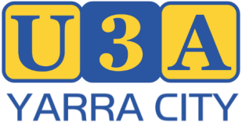

NOMINATION FORM
Election of Committee of Management Members 2026/2027 year.

All positions are declared vacant at the Annual General Meeting and nominations are invited for:

7-9 COMMITTEE MEMBERS – 1 year term

Office bearers will be elected by the Committee at the September 2026 Committee meeting.

We the undersigned Members of U3A Yarra City Inc., hereby nominate:
FULL Name

PROPOSER
Full Name

Signature:

SECONDER
Full Name

Signature:

I, ......................................................................................................
Hereby consent to this nomination. I certify that I am a member of U3A Yarra City, entitled to vote and eligible to stand for election to the U3A Yarra City committee of management.

Signature ..................................... Date ........................

Please return completed form to:
The Secretary, 17 Stanton St, Abbotsford, 3067, or by email to: secretary@u3ayarracity.org.au

